How to include graphics.h in CodeBlocks?

Compiling graphics codes on **CodeBlocks** IDE shows an error: **“Cannot find graphics.h”**. This is because graphics.h runs is not available in the library folder of CodeBlocks. To successfully compile graphics code on CodeBlocks, setup **winBGIm** library. ***WinBGIm****(Windows BGI - with mouse)*

**How to include graphics.h in CodeBlocks ?**

Please follow below steps in sequence to include “graphics.h” in CodeBlocks to successfully compile graphics code on Codeblocks.  
**Step 1 :** To setup “graphics.h” in CodeBlocks, first set up winBGIm graphics library. Download WinBGIm from <http://winbgim.codecutter.org/> or use this [link](http://www.codewithc.com/wp-content/uploads/2014/04/WinBGIm_Library6_0_Nov2005.zip).

**Step 2 :**Extract the downloaded file. There will be three files:

• graphics.h

• winbgim.h

• libbgi.a

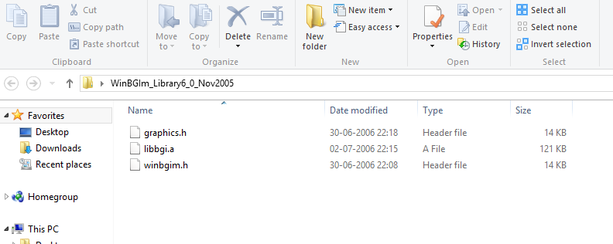

**Step 3 :** Copy and paste **graphics.h** and **winbgim.h** files into the **include** folder of compiler directory. (If you have Code::Blocks installed in C drive of your computer, go through: Disk C >> Program Files >> CodeBlocks >> MinGW >> include. Paste these two files there.)  
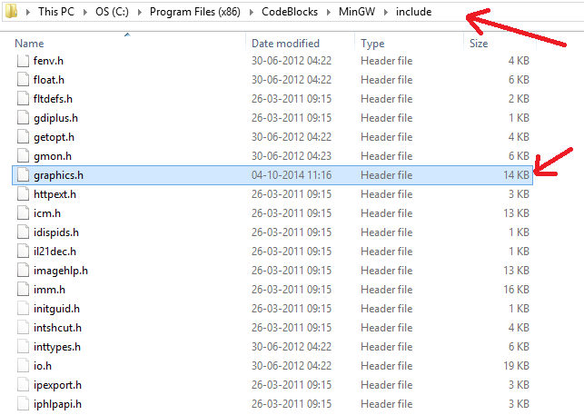

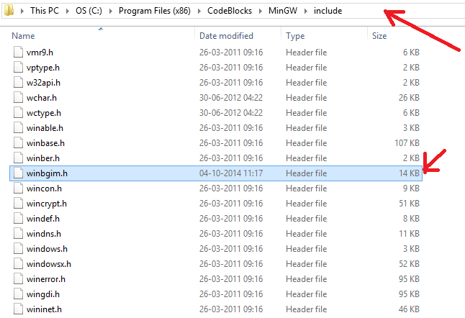

**Step 4 :** Copy and paste **libbgi.a** to the **lib** folder of compiler directory.  
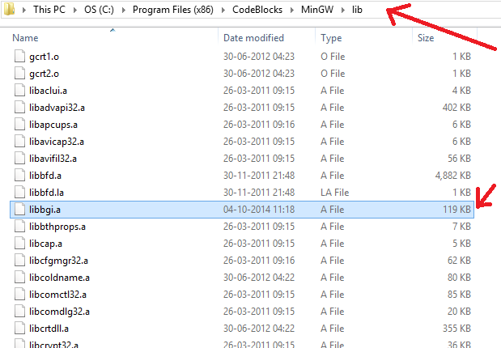

**Step 5 :**Open Code::Blocks. Go to Settings >> Compiler >> Linker settings.  
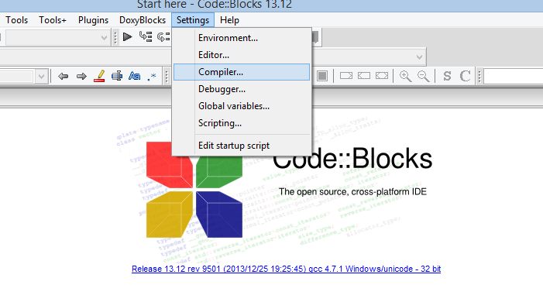

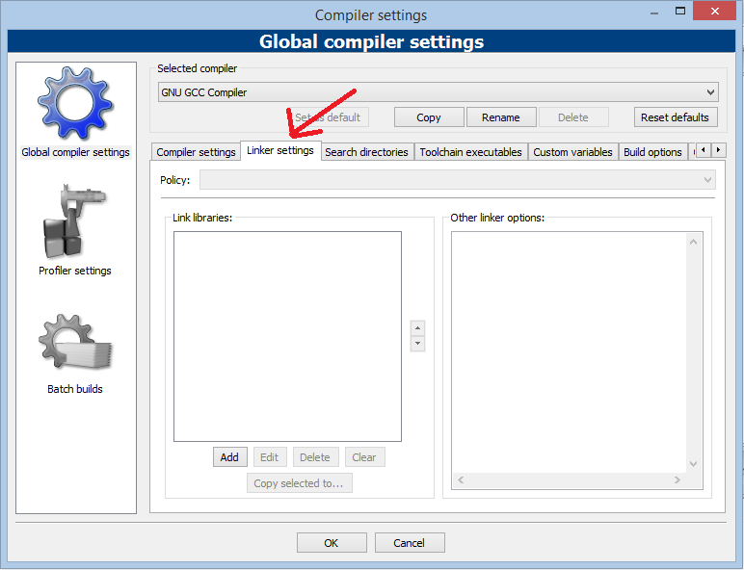

**Step 6 :** In that window, click the Add button under the “Link libraries” part, and browse.  
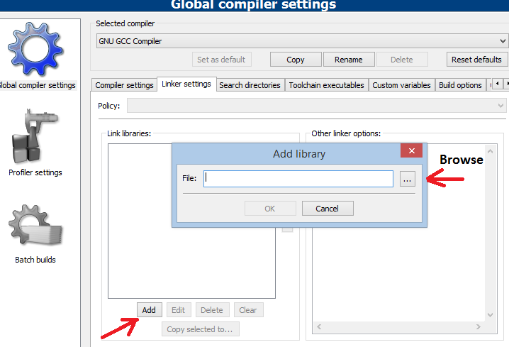  
Select the **libbgi.a** file copied to the lib folder in step 4.

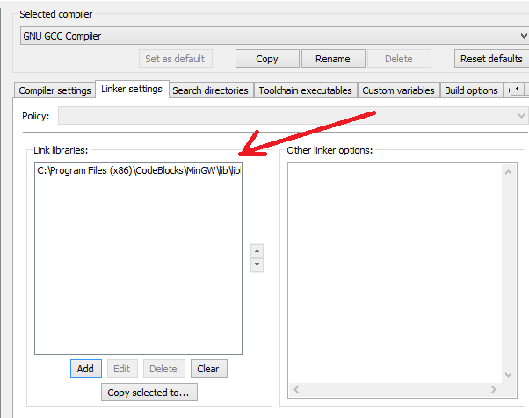

**Step 7 :** In right part (ie. other linker options) paste commands

**-lbgi -lgdi32 -lcomdlg32 -luuid -loleaut32 -lole32**

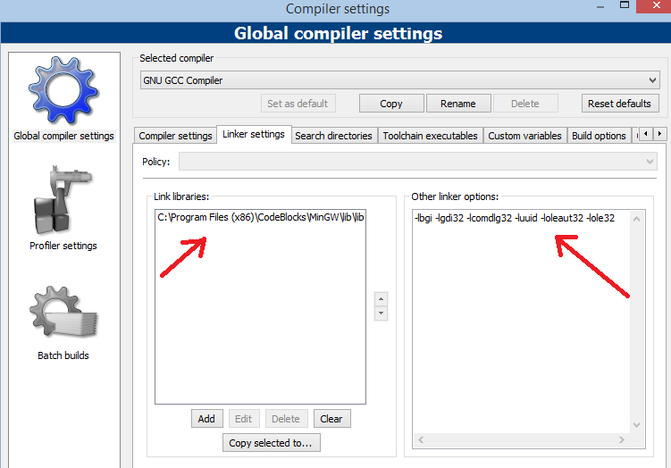

**Step 8 :** Click Ok  
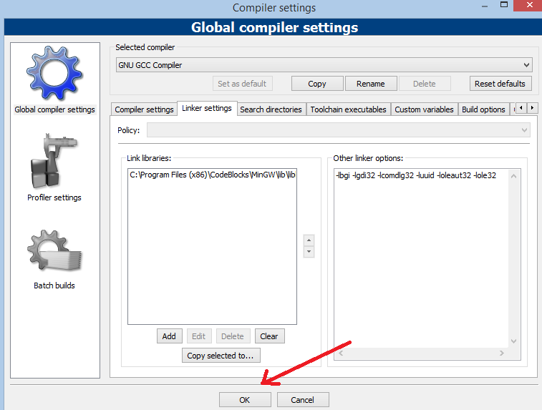

**Step 9 :** Try compiling a graphics.h program in C or C++, still there will be an error. To solve it, open graphics.h file (pasted in include folder in step 3) with Notepad++. Go to **line number 302**, and replace that line with this line :**int left=0, int top=0, int right=INT_MAX, int bottom=INT_MAX,**  
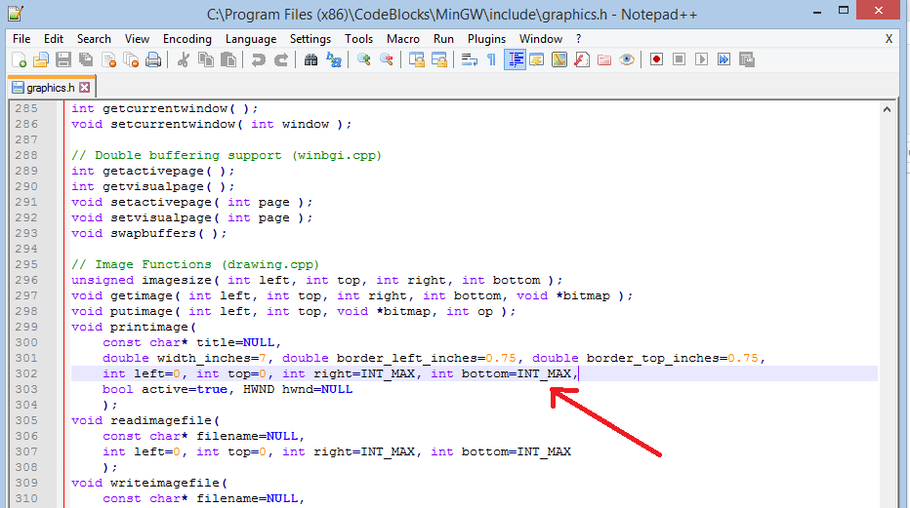

**Step 10 :** Save the file. Done !

**Note :**Now, you can compile any C or C++ program containing graphics.h header file. If you compile C codes, you’ll still get an error saying: **“fatal error: sstream : no such file directory”.**  
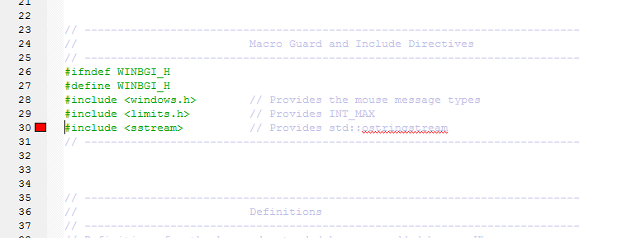

**For this issue, change your file extension to .cpp if it is .c**